iEducate: App-Related Websites

MITS iOS Apps Review
http://mitsapps.cenmi.org
MITS offers an app review site where educators and parents can add apps and explain how they use them with their parents or children. People can also add comments to an app that is already posted to share information about how they may use the app or to provide additional information about it.
The site was developed so that you could search for an app by criteria such as grade level or category.

Email Listserv about Apps
Mark.coppin@annecenter.org
Email Mark Coppin at the address above to ask Mark to put you on his apps email list. Mark sends out information about apps that have been discounted or are free for a limited time (24 to 48 hours). When you receive an email from Mark make sure to open it right away!

Apps for Children with Special Needs
http://a4cwsn.com
An extensive list of special education related apps, reviews, and videos. This is a very good resource when looking for new apps.

Autism Spectrum Directory
http://blog.autismspectrumdirectory.com
This site has a lot of information related to ASD and their apps lists (although a little difficult to navigate) are helpful. Several lists are offered by topics such as non-verbal communication, ABA, and learning social skills. Go to the blog and on the left side of the site you will see a link for “Teaching Tool: iPad and iPhone Apps.” After clicking on the link you may need to click “Read More” on the next page to see the full list of options.

Bridging Apps
http://bridgingapps.org
(Formerly Special Needs Apps for kids.)
An online community that offers lists of apps by category and also provides some reviews of highlighted apps. They also offer links to various Proloquo2Go video tutorials.

Mobile Learning for Special Needs
http://mobilelearning4specialneeds.wikispaces.com
Provides lists of apps, reviews and videos specifically for children with special needs. Check out the lists of topic specific apps when you are looking for new apps to try.

Moms with Apps 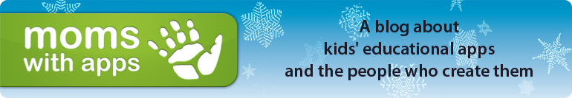
http://momswithapps.com
Moms With Apps is a collaborative group of family-friendly developers seeking to promote quality apps for kids and families. They regularly offer free or discounted apps on Fridays throughout the year. Look for App Fridays on the right side of the screen.

Pad Gadget
http://www.padgadget.com/
Pad Gadget is a comprehensive website on all things iPad. You can find app reviews as well as the latest on the iPad and its accessories. They highlight many apps although they are not all educational. They also post daily deals of apps that are on sale.

Spectronics 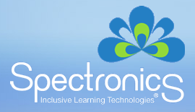
http://www.spectronicsinoz.com/article/iphoneipad-Apps-for-aac
This Australian site boasts what is probably the most complete list of AAC apps in existence. They provide prices, descriptions of apps (what symbol sets they use, customization options, voice output options, and access options), as well as a 3-star rating system.

Teaching Learners with Multiple Needs
http://teachinglearnerswithmultipleneeds.blogspot.com
Scroll down to the iPod App Round Up on the right side of the home page of this blog. Although the list is dated you will find several categories of apps that are geared specifically for users with significant disabilities.

